ACADEMIC PROJECT REPORT
DHL Knowledge Base Automation System
Knowledge Base Automation System
Student Name: Mohamed G. S. Elmashharawi
Matric Number: A23MJ0009

Table of Contents
1. Abstract / Executive Summary
2. Introduction
3. Problem Statement
4. Project Objectives
5. Project Scope
6. System Requirements
7. System Design
8. Methodology
9. Implementation
10. UiPath / RPA Integration
11. Key Features
12. Testing
13. Results and Discussion
14. Challenges Faced
15. Future Improvements
16. Conclusion
17. References
18. Appendices

1. Abstract / Executive Summary
This project presents the development of a web-based DHL Knowledge Base Automation System. The system is designed to help logistics teams manage operational information by converting raw documents and text into structured knowledge articles. The main issue addressed by this project is that logistics procedures may be stored in different formats, making them difficult to search, review, and reuse.
The system allows authenticated users to upload content, generate draft knowledge articles, view article details, edit article content, track article status, and manage version history. It also includes duplicate checking to reduce repeated knowledge records. Different user roles are supported, including editor, reviewer, and admin, to control access based on user responsibility.
The project was developed using Next.js, React, TypeScript, Tailwind CSS, Supabase, and PostgreSQL. Supabase is used for authentication, database storage, and Row Level Security policies. The backend is handled through Next.js API routes, while file processing supports text, PDF, DOCX, and image files. The system also includes an RPA results area for reviewing extracted documents and generating AI summaries using Gemini.
The final outcome is a functional academic prototype that demonstrates how logistics knowledge can be organized, reviewed, and managed through a structured web platform. Although the project is not connected to DHL’s real production systems, it provides a realistic example of how automation and secure workflows can support knowledge management in logistics operations.

2. Introduction
In logistics operations, accurate information is important for completing tasks correctly and consistently. Employees often depend on procedures, documents, and operational notes to understand how specific tasks should be handled. However, when this information is stored in different files or locations, it becomes difficult to manage and reuse.
The DHL Knowledge Base Automation System was developed to provide a central platform for managing logistics knowledge. The system helps convert raw content into knowledge articles that can be reviewed, updated, and published. This makes information easier to organize and access.
The system also applies role-based access control. This means users can only perform actions that match their responsibilities. For example, editors can create and edit draft articles, while admins can manage article status changes, delete articles, and access RPA extraction results.
This project uses modern web technologies such as Next.js, TypeScript, Supabase, and PostgreSQL. These technologies support secure authentication, structured database storage, and maintainable web application development.

3. Problem Statement
In logistics operations, important procedures are often stored in different formats such as PDFs, text files, images, DOCX files, and internal notes. This makes it difficult for employees to quickly find, update, and reuse information.
Creating knowledge articles manually also takes time because staff need to read documents, extract key points, and rewrite them in a clear format. This can lead to inconsistent article quality.
Another issue is duplicated content. Similar documents may be uploaded more than once, which can confuse users and make the knowledge base harder to maintain.
This project solves these problems by providing a web-based system that organizes logistics documents, generates draft knowledge articles, detects possible duplicates, and manages article review using role-based access control.

4. Project Objectives
The main objective of this project is to develop a web-based system that helps manage logistics knowledge in a more organized and secure way.
The specific objectives are:
• To develop a knowledge base platform for storing and managing logistics articles.
• To allow users to upload text or documents and generate draft knowledge articles.
• To support article creation, editing, reviewing, and publishing.
• To provide role-based access control for editor, reviewer, and admin users.
• To reduce duplicated content using exact and similar duplicate checking.
• To provide an admin area for reviewing RPA extraction results.
• To support future automation workflows using UiPath and extracted document data.

5. Project Scope

5.1 Included in the Project
This project includes:
• User login and authentication.
• Role-based profiles for editor, reviewer, and admin users.
• Upload console for text and supported document files.
• Support for TXT, PDF, DOCX, and image file processing.
• AI-assisted draft article generation with fallback processing.
• Knowledge article listing.
• Article search and filtering.
• Article detail page with summary, procedure steps, tags, and source text.
• Article editing with version history.
• Article status workflow using draft, reviewed, and published.
• Duplicate and conflict flagging.
• Admin-only article deletion.
• Admin-only RPA extraction results page.
• AI summary generation for extracted RPA documents.
• Supabase database and Row Level Security policies.

5.2 Not Included in the Project
This project does not include:
• Full deployment inside DHL’s real internal system.
• Direct connection to DHL production databases.
• Mobile application development.
• Enterprise-level automation deployment.
• Advanced custom AI model training.
• Full production monitoring and logging system.
Screenshot placeholder: Main Dashboard
Figure 1: Main dashboard showing the system overview and key knowledge base statistics.

6. System Requirements

6.1 Functional Requirements
The system should allow users to:
• Log in securely using Supabase authentication.
• Access pages based on their assigned role.
• Upload raw text or supported files.
• Generate draft knowledge articles from uploaded content.
• View all knowledge articles.
• Search and filter knowledge articles.
• Open an article detail page.
• View article summary, procedure steps, tags, and source document text.
• Edit article title, summary, steps, and tags.
• Save article version history after edits.
• Change article status through the workflow.
• Delete articles if the user is an admin.
• View RPA extraction results if the user is an admin.
• Generate AI summaries for extracted RPA documents.

6.2 Non-Functional Requirements
The system should be:
• Secure: users must be authenticated before accessing protected pages.
• Role-based: sensitive actions should be limited to the correct user role.
• User-friendly: the interface should be simple and clear.
• Reliable: article and document data should be stored correctly.
• Maintainable: the code and database structure should be organized.
• Validated: invalid inputs should be rejected by the API.
• Scalable: the system should allow future features such as pagination, advanced search, and more detailed automation.
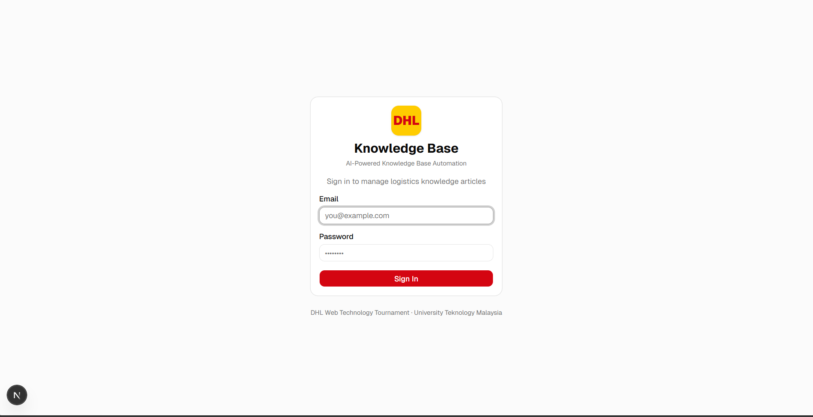Figure 2: Login page where authorized users can securely access the system.

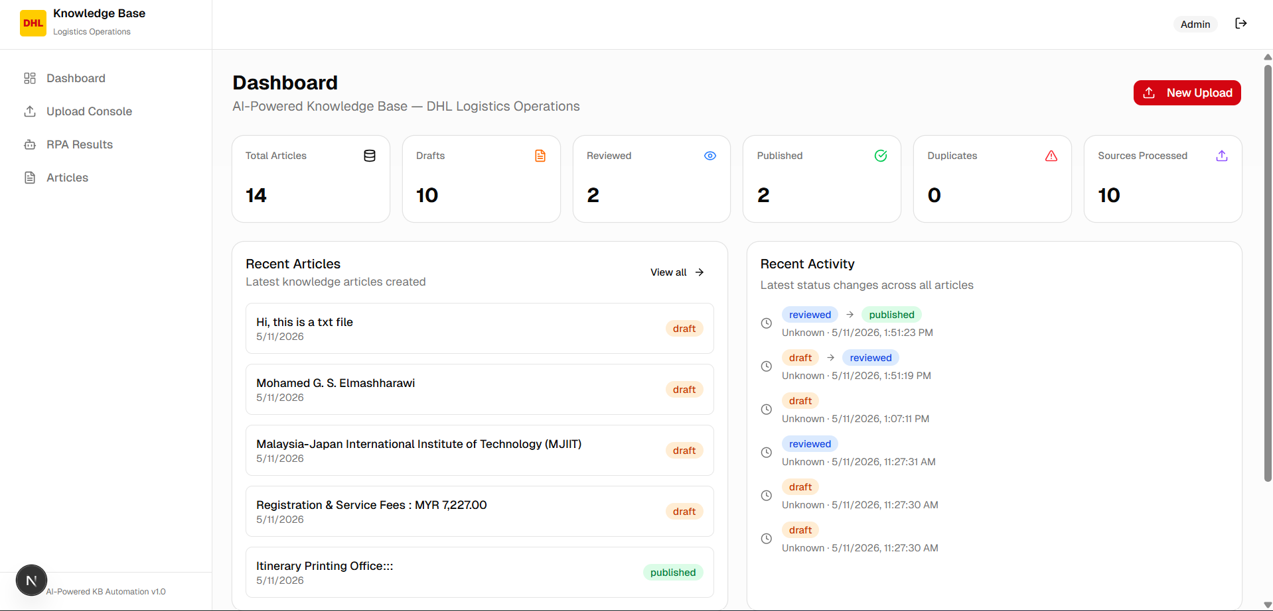Figure 3: Main dashboard showing article statistics, recent articles, recent activity, and quick actions.

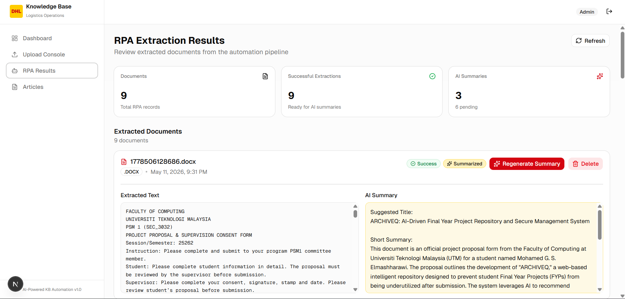Figure 4: Role-based access control showing that restricted pages are only available to authorized users.

7. System Design

7.1 System Architecture
The system follows a web-based client-server architecture. The frontend is built using Next.js and React, while the backend logic is handled through Next.js API routes. Supabase is used for user authentication, database storage, and security policies.
The main architecture includes:
• Frontend: Next.js, React, TypeScript, Tailwind CSS, and reusable UI components.
• Backend: Next.js API routes for upload processing, article management, status updates, and RPA summary generation.
• Database: Supabase PostgreSQL for storing profiles, source documents, articles, steps, tags, versions, status history, processing logs, and RPA extracted documents.
• Authentication: Supabase Auth for managing user login sessions.
• Storage: Supabase Storage for uploaded document files.
• AI Processing: OpenAI API support for draft generation when configured, fallback processing when unavailable, and Gemini API for RPA document summaries.
• Automation Support: UiPath/RPA workflow support through extracted document records and an admin RPA results page.

7.2 Use Case Diagram
The main actors in the system are:
• Editor: uploads content, creates draft articles, and edits allowed articles.
• Reviewer: represents users involved in review-based workflows.
• Admin: manages article status, deletes articles, views RPA results, deletes RPA records, and generates AI summaries.
• UiPath / RPA Bot: extracts document data for automation workflow support.
Main use cases include:
• Login.
• Upload content.
• Generate draft article.
• View article list.
• Search and filter articles.
• View article details.
• Edit article.
• View version history.
• Change article status.
• Delete article.
• View RPA extraction results.
• Generate AI summary for extracted documents.

7.3 Database Design
The database is designed using Supabase PostgreSQL. It stores user profiles, uploaded source documents, article data, workflow history, processing logs, and RPA extraction records.
Main tables include:
Table Name: profiles
Purpose: Stores user profile information and role values.
Table Name: source_documents
Purpose: Stores uploaded or pasted source content before article creation.
Table Name: knowledge_articles
Purpose: Stores the main article records such as title, summary, status, and flags.
Table Name: article_steps
Purpose: Stores ordered procedure steps for each article.
Table Name: article_tags
Purpose: Stores tags assigned to articles.
Table Name: article_versions
Purpose: Stores snapshots of article changes.
Table Name: status_history
Purpose: Stores article status transition records.
Table Name: processing_logs
Purpose: Stores extraction and processing activity logs.
Table Name: rpaextracteddocuments
Purpose: Stores extracted document results from the RPA workflow.

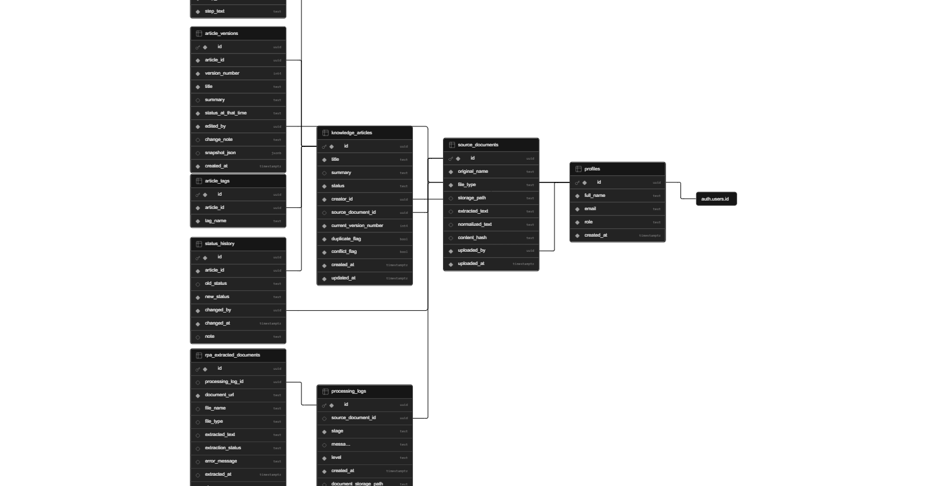
Figure 5: Supabase database tables used to store users, articles, documents, and workflow data.

8. Methodology
This project used an Agile development approach. The system was built in small stages, and each feature was tested after implementation. This approach made it easier to fix problems during development and improve the system step by step.
The development phases were:
1. Requirement Analysis
The main system requirements were identified, including upload processing, article management, user roles, and RPA support.
1. UI Design
The main screens were planned, including login, dashboard, upload console, article list, article details, and RPA results.
1. Database Design
Supabase PostgreSQL tables were created to store users, articles, documents, versions, status history, logs, and RPA extraction records.
1. Backend Development
API routes were implemented for upload processing, article listing, article editing, article deletion, status changes, and RPA summary generation.
1. Frontend Development
The dashboard pages were developed using Next.js, React, TypeScript, Tailwind CSS, and reusable UI components.
1. Security Implementation
Authentication, role checks, Row Level Security policies, and API input validation were added.
1. Testing and Debugging
The system was tested using browser testing, API testing, Supabase testing, and build/lint checks.
1. Final Improvement
The system was improved by adding filtering, version history, duplicate checking, and RPA results features.

9. Implementation

9.1 Frontend Implementation
The frontend was developed using Next.js, React, TypeScript, Tailwind CSS, and reusable UI components. The interface is designed to be simple and easy to use.
The main frontend pages include:
• Dashboard Page: displays article statistics, recent articles, recent activity, and quick actions.
• Upload Console: allows users to upload files or paste raw text.
• Article List Page: displays all articles with search and filtering options.
• Article Detail Page: shows article summary, steps, tags, source text, edit form, and history.
• RPA Results Page: allows admins to review extracted documents and generate AI summaries.
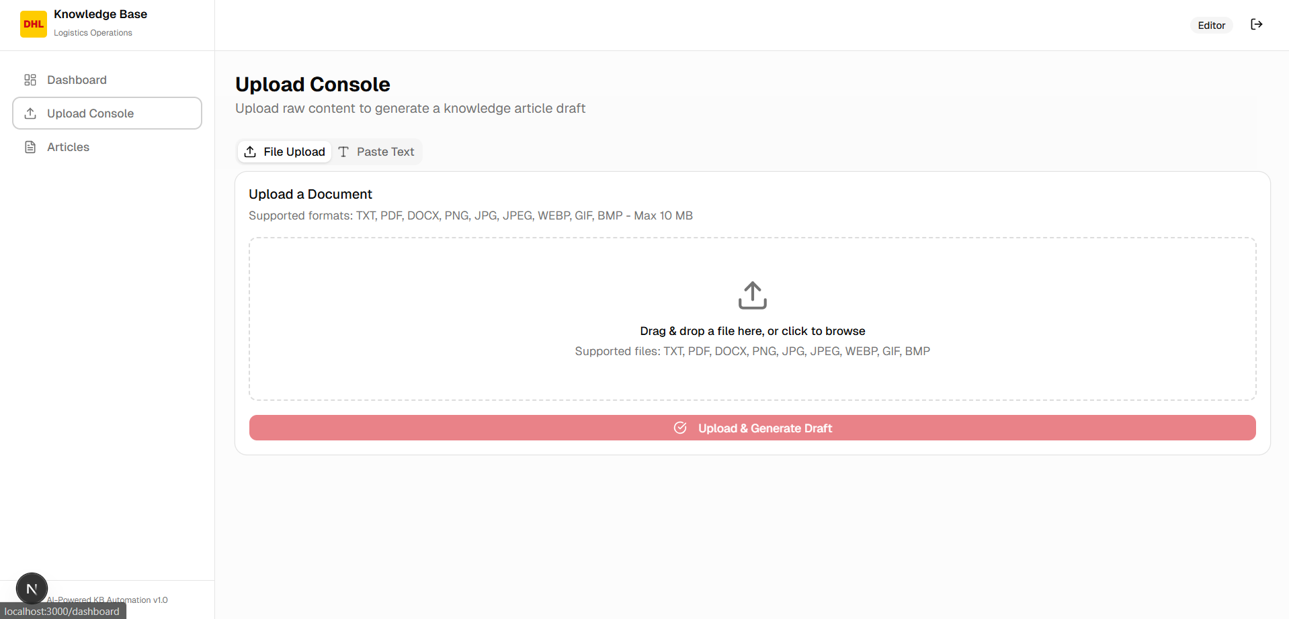Figure 6: Upload console where users can upload files or paste raw logistics text.

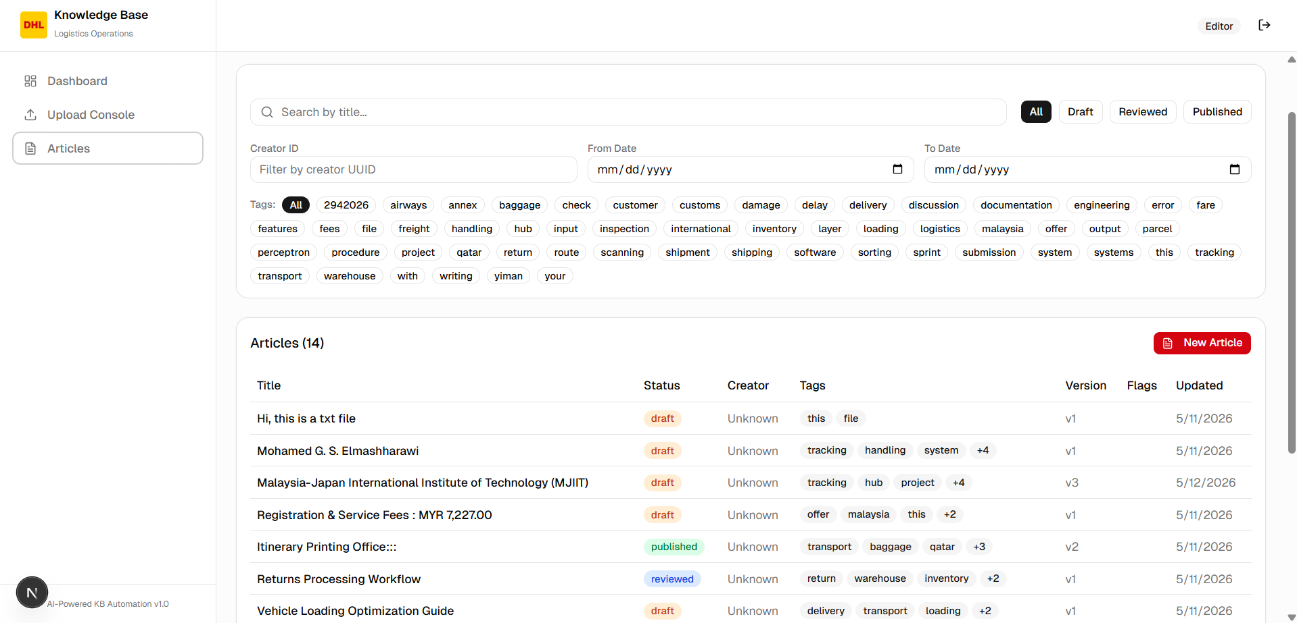Figure 7: Article list page showing knowledge articles with search and filtering options.

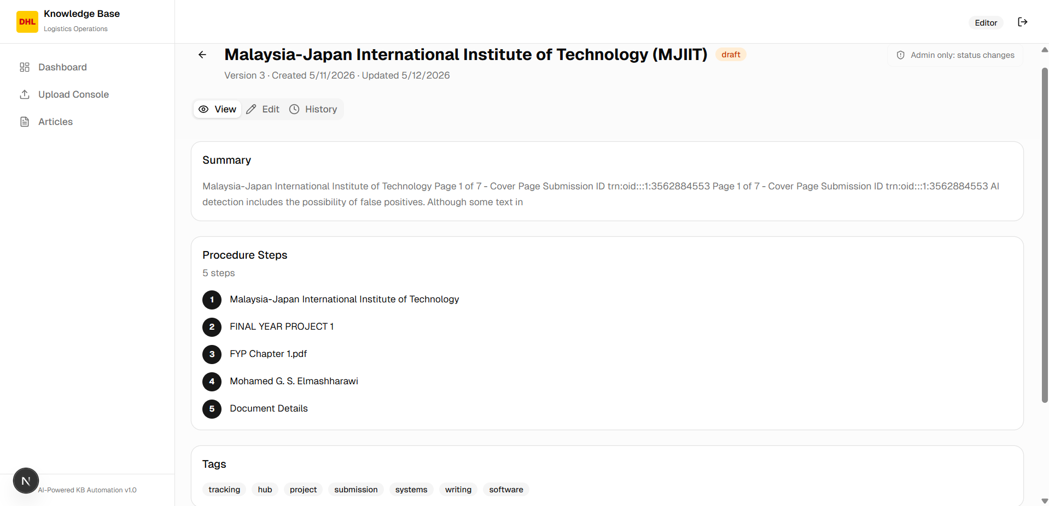Figure 8: Article details page showing the article summary, procedure steps, tags, and source document text.

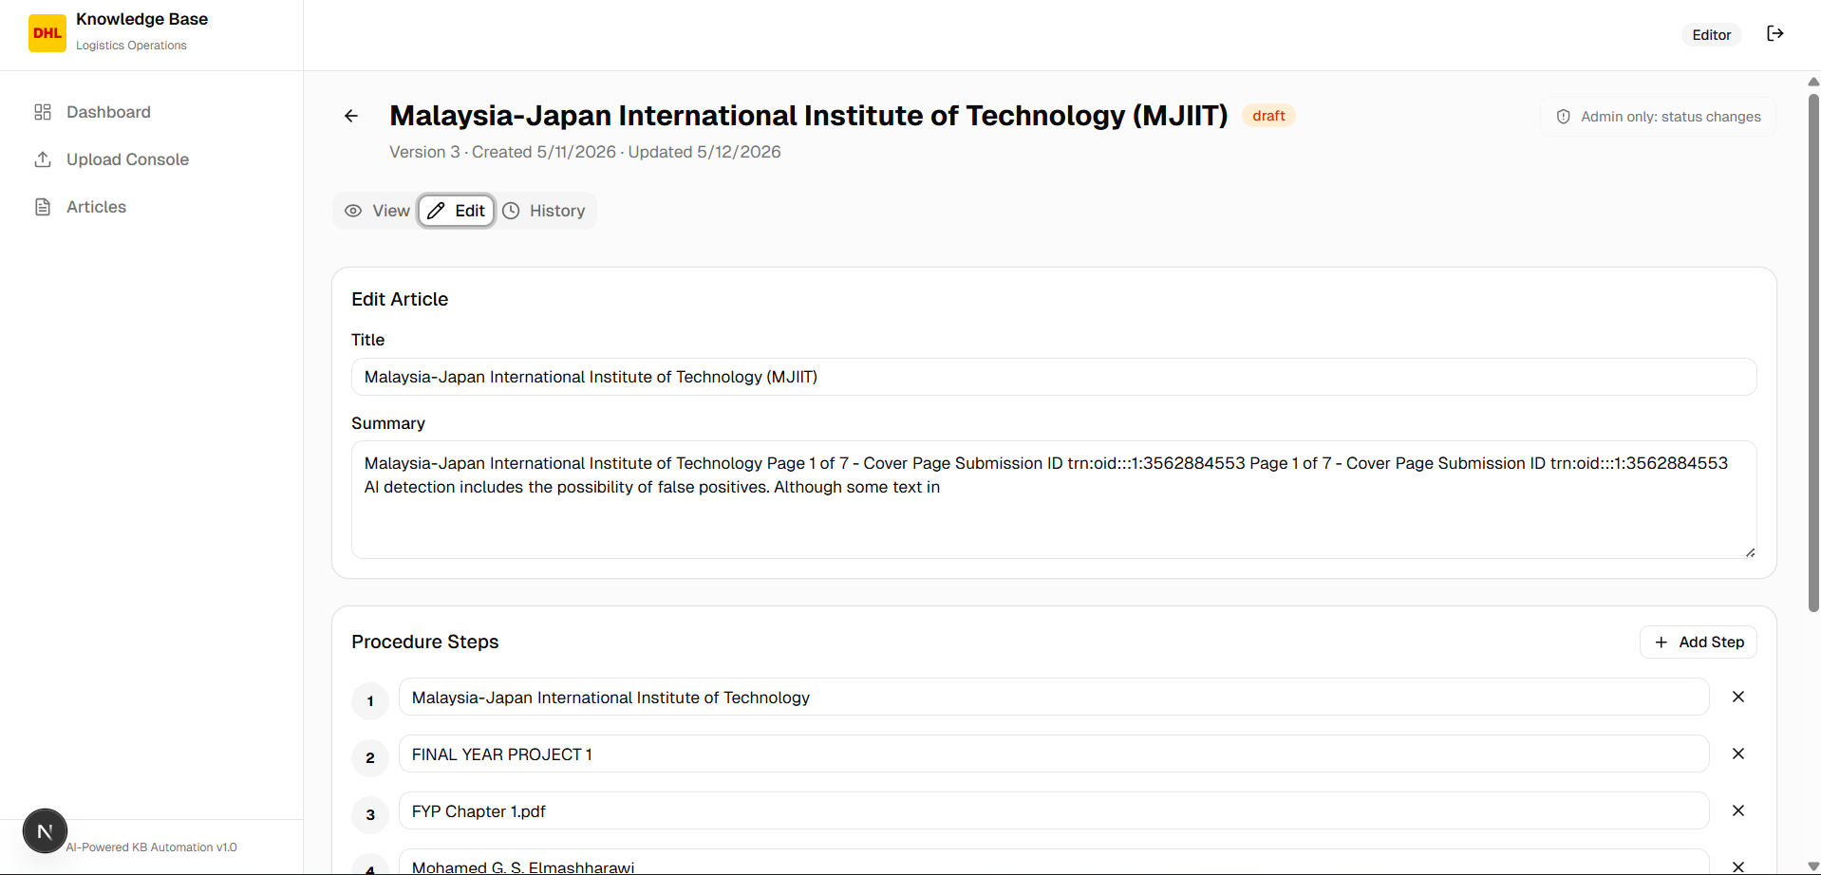Figure 9: Article edit interface used to update article content and save a new version.

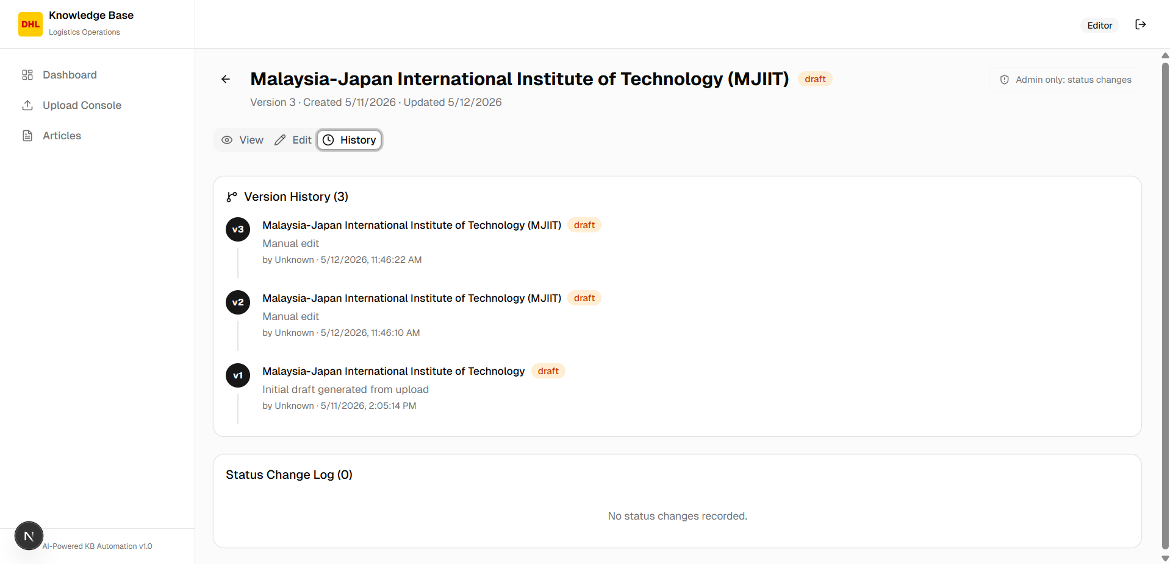Figure 10: Version history showing previous changes made to the article.

9.2 Backend Implementation
The backend is implemented using Next.js API routes. These routes handle the main system operations, including article management, upload processing, status updates, and RPA document summarization.
Main backend routes include:
API Route: POST /api/process-upload
Purpose: Processes uploaded files or pasted text and creates a draft article.
API Route: GET /api/articles
Purpose: Retrieves articles with search and filtering options.
API Route: GET /api/articles/:id
Purpose: Retrieves a single article with steps, tags, and creator details.
API Route: PATCH /api/articles/:id
Purpose: Updates article content and creates a new version record.
API Route: DELETE /api/articles/:id
Purpose: Deletes an article, restricted to admin users.
API Route: PATCH /api/articles/:id/status
Purpose: Changes article status, restricted to admin users.
API Route: POST /api/rpa/summarize
Purpose: Generates an AI summary for an extracted RPA document.
API Route: DELETE /api/rpa/documents/:id
Purpose: Deletes an RPA extracted document record, restricted to admin users.
The backend also includes validation using Zod. This helps reject invalid article IDs, invalid request bodies, unsupported status values, and incorrect document IDs.

9.3 Upload and Draft Generation
The upload feature allows users to provide content in two ways:
• Upload a supported file.
• Paste raw text directly into the system.
Supported file types include:
• TXT
• PDF
• DOCX
• PNG
• JPG / JPEG
• WEBP
• GIF
• BMP
The maximum file size is 10 MB.
After the content is received, the system extracts text from the input, normalizes the text, creates a content hash, stores the source document, generates a draft article, checks for possible duplicates, saves article steps and tags, creates the first article version, and records the initial status history.
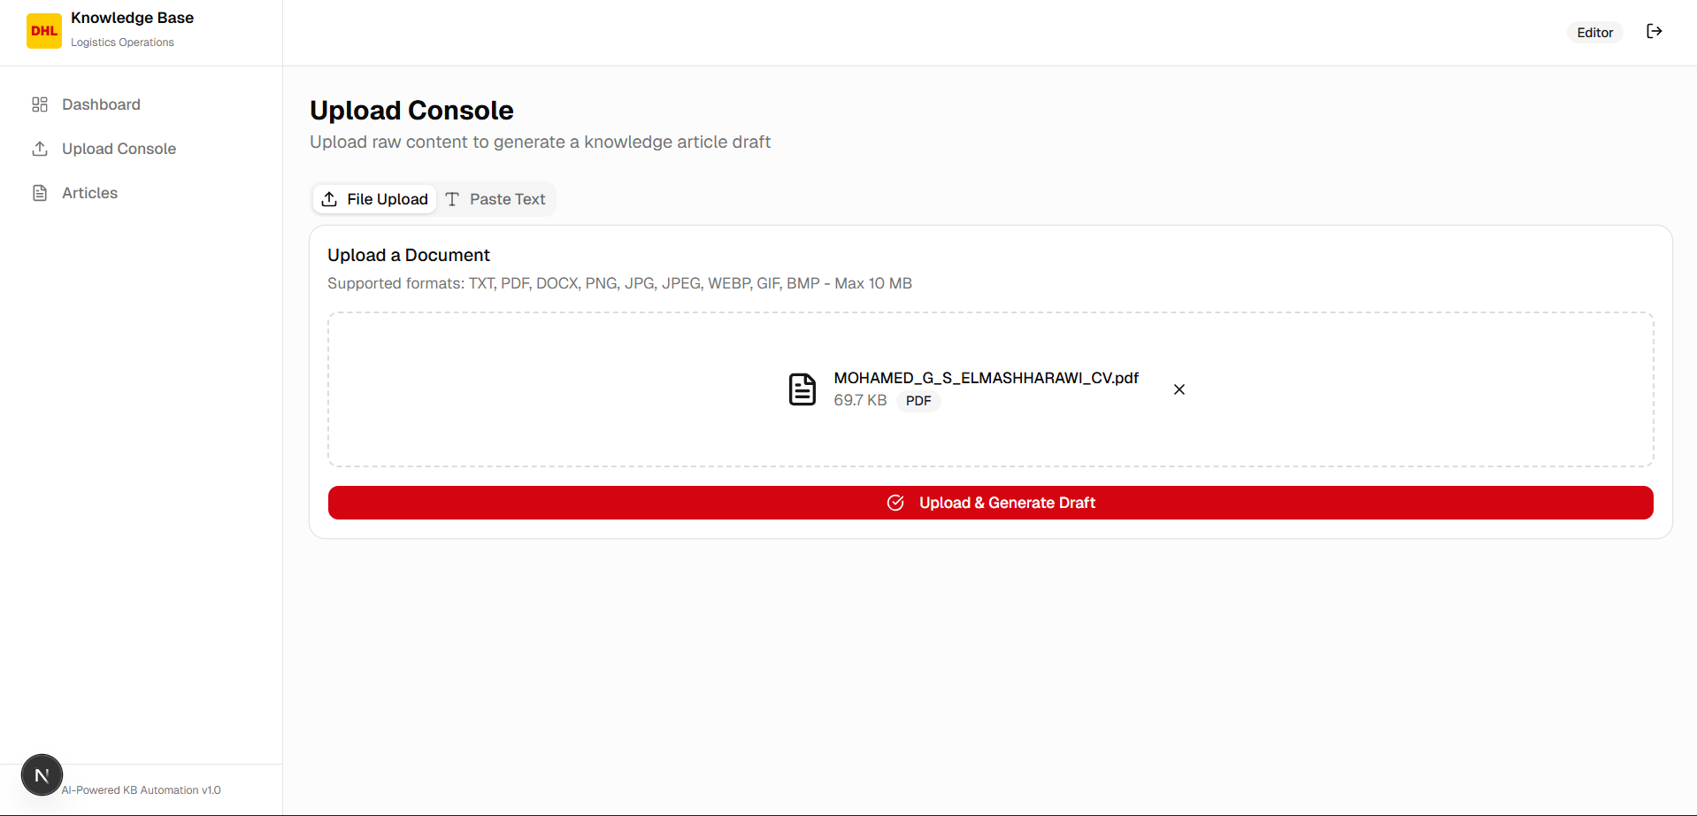Figure 11: File upload section showing a selected document ready for processing.

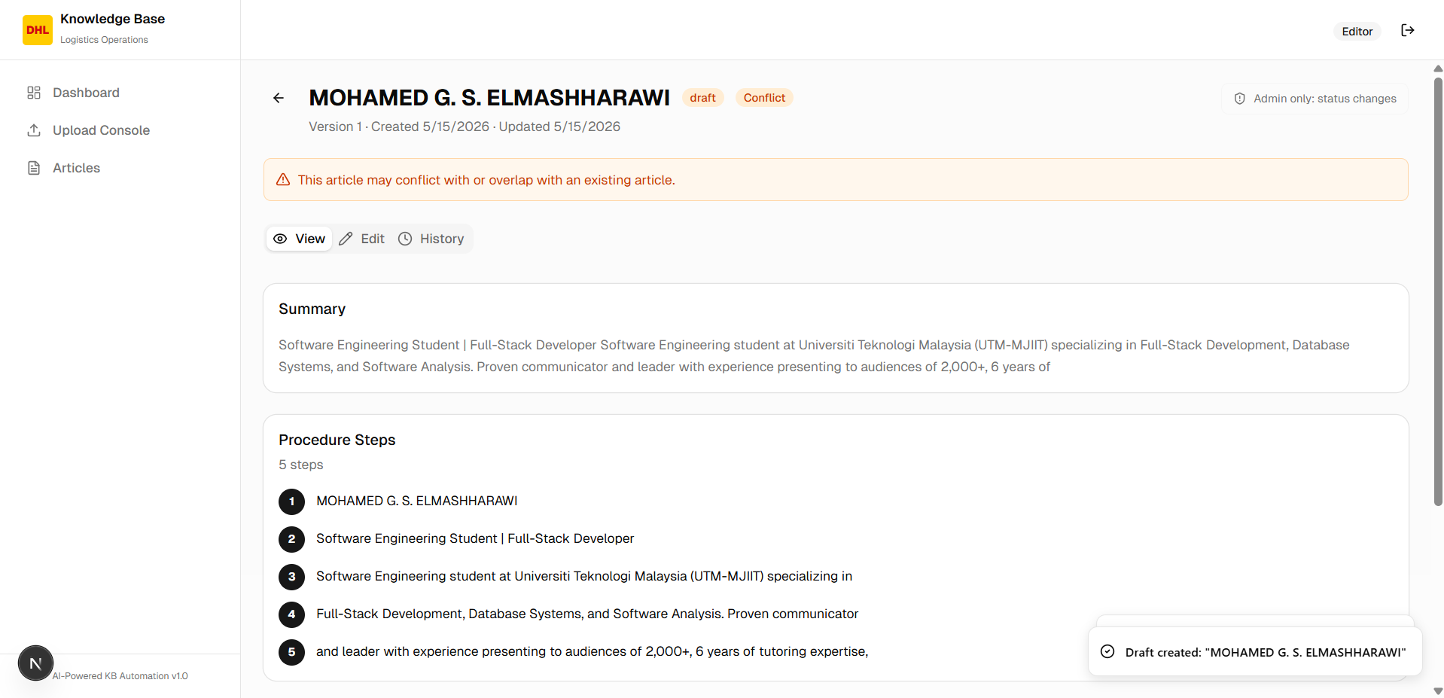Figure 12: Draft article generated after processing uploaded content.

9.4 Article Management
Articles are stored in the knowledge_articles table. Each article includes a title, summary, status, creator ID, source document ID, version number, duplicate flag, conflict flag, and timestamps.
The article detail page displays:
• Article title.
• Current status.
• Duplicate or conflict warning.
• Current version number.
• Summary.
• Procedure steps.
• Tags.
• Source document information.
• Extracted source text.
• Edit tab.
• History tab.
Article editing is controlled by permission rules. Admins can edit articles, while the creator can edit their own article only while it is still in draft status.

9.5 Status Workflow
The system uses three article statuses:
• draft
• reviewed
• published
The implemented status transition rules are:
Current Status: draft
Allowed Next Status: reviewed
Current Status: reviewed
Allowed Next Status: published, draft
Current Status: published
Allowed Next Status: draft
Only admin users can change article status in the current implementation. Every status change is saved in the status_history table.
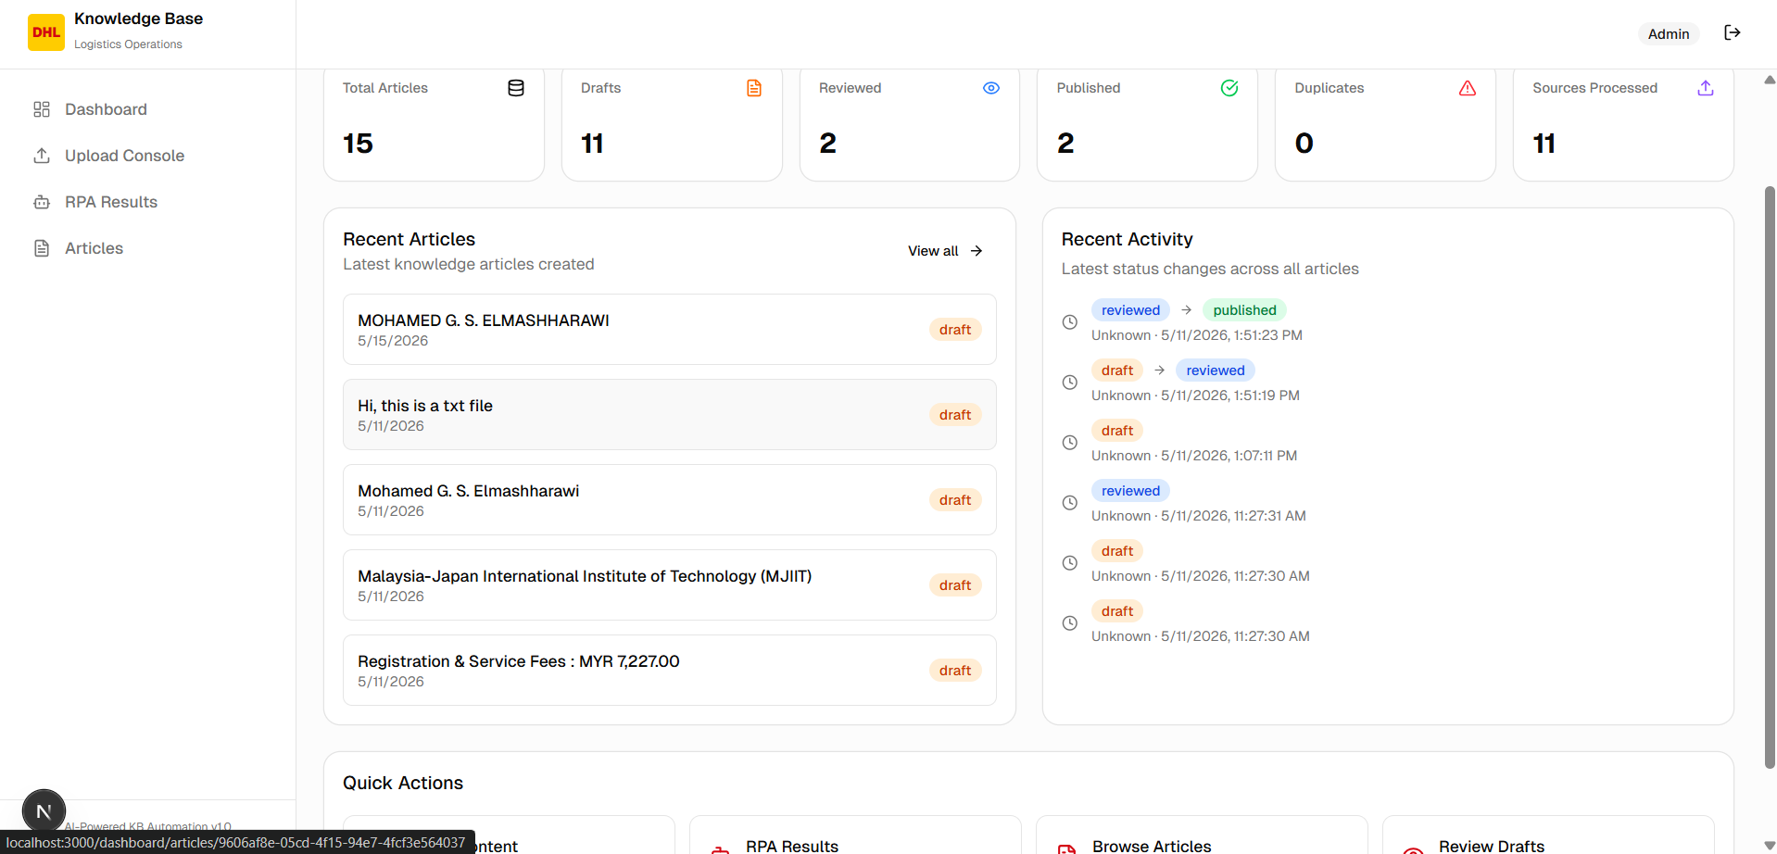Figure 13: Article status controls used by admins to move articles through the workflow.

9.6 Duplicate Detection
The system checks for duplicate content during upload processing. It uses two methods:
• Exact duplicate checking: compares the content hash of the uploaded document with existing source documents.
• Similar duplicate checking: searches article titles using important keywords from the generated title.
If a duplicate is found, the article is flagged using either:
• duplicate_flag
• conflict_flag
This helps users identify repeated or overlapping content before publishing.

9.7 Database Implementation
Supabase PostgreSQL is used to store system data. Foreign keys connect related tables such as articles, steps, tags, versions, and status history. The database also stores processing logs and RPA extraction records.
Row Level Security is enabled on the main tables. These policies help control direct database access and protect system data based on authenticated user sessions and user roles.

9.8 Security Implementation
The system includes several security controls:
• Supabase authentication.
• Role-based profile records.
• Admin-only access for sensitive pages.
• Admin-only article deletion.
• Admin-only status changes.
• Admin-only RPA results access.
• Row Level Security policies.
• Zod validation for API inputs.
• Service role usage only on the server side.
• Environment variables for private keys.
These controls help reduce unauthorized access and protect important system operations.

10. UiPath / RPA Integration
The project includes an RPA results workflow to support automation output from UiPath or similar RPA tools. The system stores extracted document records in the rpa_extracted_documents table. Admin users can view these records from the RPA results page.
The RPA results page displays:
• Total extracted documents.
• Successful extraction count.
• Failed extraction count.
• AI summary count.
• Extracted document text.
• Extraction status.
• AI summary status.
Admin users can generate or regenerate an AI summary for an extracted document. This summary is generated using Gemini and saved back into the database.
This design supports a future workflow where UiPath extracts text from logistics documents, sends or stores the result, and the web system allows admins to review and summarize the extracted content.

11. Key Features

11.1 User Authentication
Users must log in before accessing the protected dashboard. Authentication is handled using Supabase Auth.

11.2 Role-Based Access Control
The system uses user roles such as editor, reviewer, and admin. Admin users have access to sensitive actions such as deleting articles, changing article status, and viewing RPA results.

11.3 Upload Console
Users can upload supported files or paste text directly. The system extracts the content and starts the draft generation process.

11.4 AI-Assisted Draft Generation
The system can generate a draft knowledge article from extracted content. If the AI API is not available, a deterministic fallback processor is used.

11.5 Article Management
Users can view, search, filter, edit, and manage knowledge articles through the dashboard.

11.6 Article Filtering
The article list supports filtering by status, search keyword, tag, creator ID, and date range.

11.7 Version History
When an article is edited, the system creates a new version record. This allows changes to be tracked over time.

11.8 Status Workflow
Articles move through a controlled workflow using the statuses draft, reviewed, and published.

11.9 Duplicate Detection
The system detects exact and similar content to reduce repeated articles.

11.10 RPA Results Management
Admin users can review RPA extracted documents, delete records, and generate AI summaries.

12. Testing
Testing was done to check the main system functions, user permissions, API validation, and database behavior.
Testing methods included:
• Manual browser testing.
• API testing.
• Supabase database testing.
• Role permission testing.
• File upload testing.
• RPA results testing.
• Lint and build testing.
Test Case: Login with valid user
Expected Result: User enters dashboard
Actual Result: Works successfully
Status: Pass
Test Case: Login with invalid user
Expected Result: Access is denied
Actual Result: Works successfully
Status: Pass
Test Case: Upload text input
Expected Result: Draft article is created
Actual Result: Works successfully
Status: Pass
Test Case: Upload supported file
Expected Result: File is processed and draft is created
Actual Result: Works successfully
Status: Pass
Test Case: Upload unsupported file
Expected Result: System rejects the file
Actual Result: Works successfully
Status: Pass
Test Case: View article list
Expected Result: Articles are displayed
Actual Result: Works successfully
Status: Pass
Test Case: Search articles
Expected Result: Matching articles are shown
Actual Result: Works successfully
Status: Pass
Test Case: Filter by status
Expected Result: Correct status articles are shown
Actual Result: Works successfully
Status: Pass
Test Case: Open article details
Expected Result: Full article content is displayed
Actual Result: Works successfully
Status: Pass
Test Case: Edit draft article
Expected Result: Article updates and new version is created
Actual Result: Works successfully
Status: Pass
Test Case: Unauthorized user edits restricted article
Expected Result: Access is denied
Actual Result: Works successfully
Status: Pass
Test Case: Admin changes article status
Expected Result: Status changes and history is saved
Actual Result: Works successfully
Status: Pass
Test Case: Non-admin changes article status
Expected Result: Access is denied
Actual Result: Works successfully
Status: Pass
Test Case: Admin deletes article
Expected Result: Article is deleted
Actual Result: Works successfully
Status: Pass
Test Case: Non-admin deletes article
Expected Result: Access is denied
Actual Result: Works successfully
Status: Pass
Test Case: Duplicate document upload
Expected Result: Duplicate or conflict flag appears
Actual Result: Works successfully
Status: Pass
Test Case: Admin views RPA results
Expected Result: Extracted documents are displayed
Actual Result: Works successfully
Status: Pass
Test Case: Non-admin views RPA results
Expected Result: Access is restricted
Actual Result: Works successfully
Status: Pass
Test Case: Generate RPA AI summary
Expected Result: Summary is generated and saved
Actual Result: Works successfully
Status: Pass
Commands used during development testing:
npm run lint
npm run build
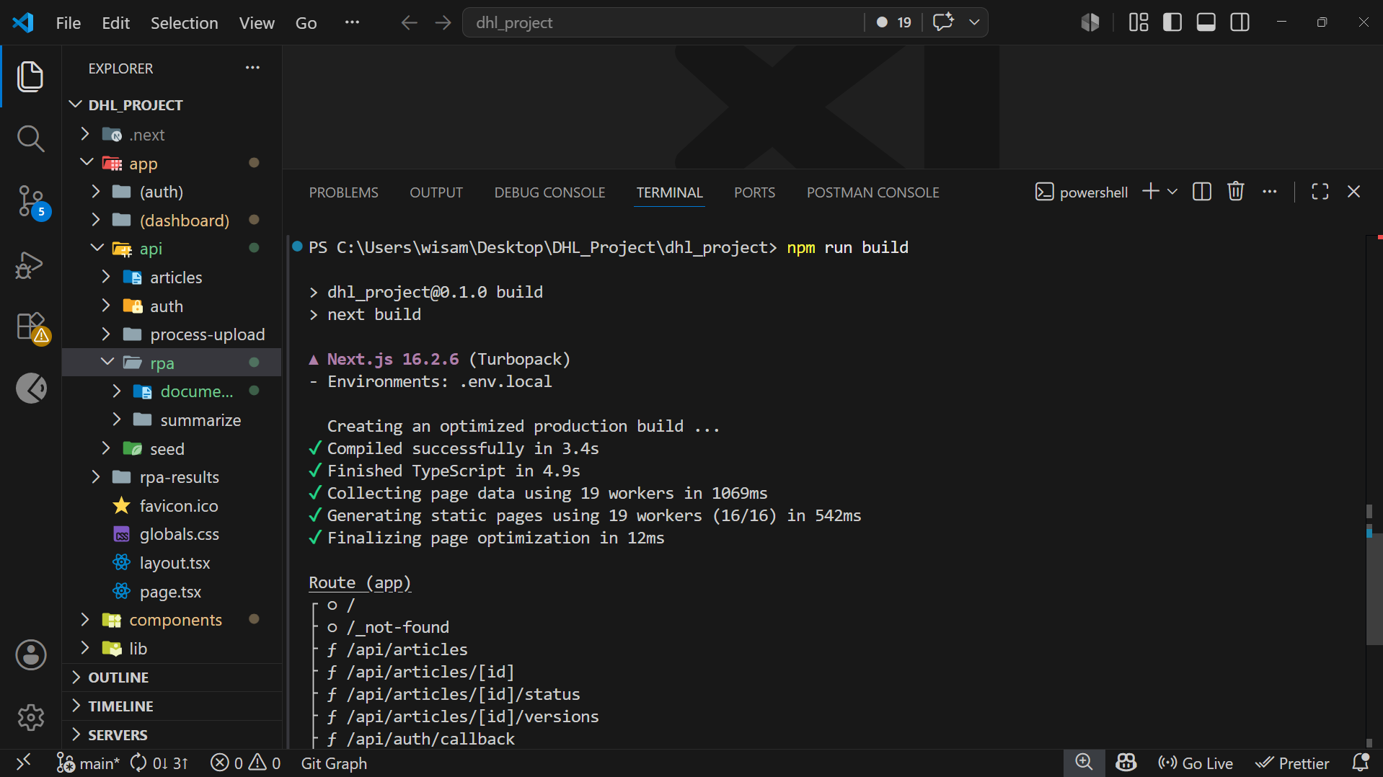Figure 14: Successful build result showing that the project compiles correctly.

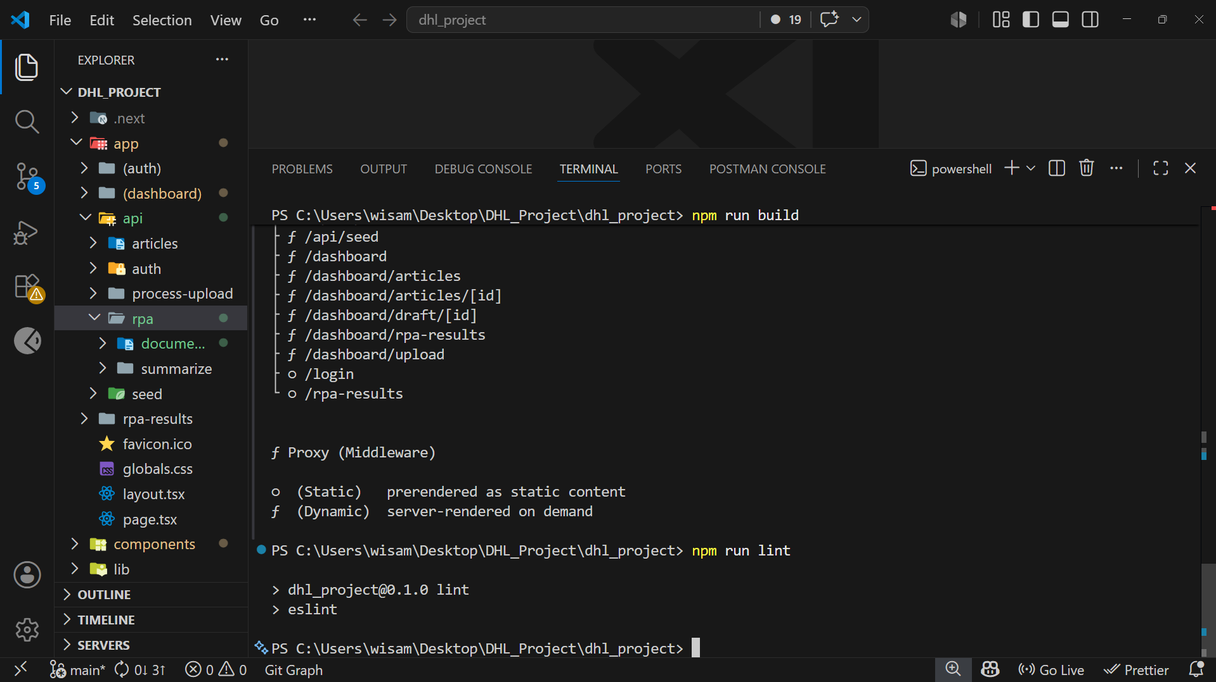Figure 15: Successful lint result showing that code quality checks passed.

13. Results and Discussion
The project successfully produced a working knowledge base automation prototype. The system can receive raw content, extract text, generate a draft article, save article steps and tags, and display the article inside the dashboard.
The dashboard gives users a clear overview of total articles, drafts, reviewed articles, published articles, duplicates, and processed sources. This helps users understand the current state of the knowledge base.
The article management workflow also improves organization. Users can search and filter articles, view full article details, edit drafts, and track version history. Admin users can move articles through the workflow and manage sensitive actions.
The RPA results page supports automation output by allowing admins to review extracted documents and generate AI summaries. This makes the system more suitable for future integration with UiPath workflows.
However, the system is still an academic prototype. It is not connected to DHL’s real internal systems, and more testing would be required before production use. AI-generated and extracted content should also be reviewed by a human before being published.

14. Challenges Faced
Several challenges were faced during the project development:
• Designing a database structure that connects articles, source documents, steps, tags, versions, and status history.
• Setting up Supabase authentication and user roles.
• Managing Row Level Security policies.
• Handling article permissions correctly.
• Validating API inputs using Zod.
• Supporting different file types for upload and text extraction.
• Adding OCR support for image files.
• Creating article version history after edits.
• Handling duplicate and similar content detection.
• Restricting RPA results to admin users only.
• Keeping the system organized while adding new features.

15. Future Improvements
The system can be improved in the future by adding:
• Pagination for large article lists.
• Advanced full-text search.
• More detailed reviewer permissions.
• Notification system for article review updates.
• File preview before article generation.
• Better AI formatting for generated articles.
• More detailed audit logs.
• Automated unit and integration tests.
• Improved UiPath workflow connection.
• Direct API endpoint for receiving RPA extraction data.
• Production monitoring and error reporting.
• Deployment inside a real organization environment.

16. Conclusion
The DHL Knowledge Base Automation System is a web-based project designed to improve the way logistics knowledge is organized and managed. It allows users to upload content, generate draft articles, manage article status, track changes, and reduce duplicated information.
The system was built using Next.js, TypeScript, Tailwind CSS, Supabase, and PostgreSQL. It also includes AI-assisted draft generation, role-based access control, version history, duplicate checking, and an admin RPA results page.
Overall, the project demonstrates how automation and structured workflows can support knowledge management in logistics operations. Although it is not connected to DHL’s real production environment, it provides a strong academic prototype that can be extended into a more complete system in the future.

17. References
• Next.js Documentation.
• React Documentation.
• Supabase Documentation.
• PostgreSQL Documentation.
• Tailwind CSS Documentation.
• UiPath Documentation.
• Google Gemini API Documentation.
• OpenAI API Documentation.
• Knowledge management and role-based access control references.

18. Appendices

Appendix A: API Examples
Example article list request:
GET /api/articles?status=draft&search=shipment
Example article status update request:
PATCH /api/articles/:id/status
Content-Type: application/json
{
"newStatus": "reviewed",
"note": "Article checked and ready for publishing review."
}
Example RPA summary request:
POST /api/rpa/summarize
Content-Type: application/json
{
"id": "rpa-document-uuid"
}

Appendix B: Setup Summary
Basic local setup steps:
npm install
npm run dev
Supabase setup:
1. Create a Supabase project.
2. Run supabase/schema.sql.
3. Run supabase/policies.sql.
4. Create the uploads storage bucket.
5. Fill the environment variables in .env.local.

Appendix C: Important Environment Variables
NEXT_PUBLIC_SUPABASE_URL=
NEXT_PUBLIC_SUPABASE_ANON_KEY=
SUPABASE_SERVICE_ROLE_KEY=
GEMINI_API_KEY=
OPENAI_API_KEY=
NEXT_PUBLIC_APP_URL=

